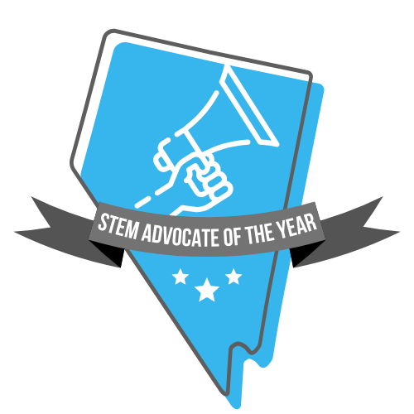
Nevada STEM Advocate of the Year Scoring Rubric

Each criterion will be scored individually by the reviewers (OSIT, NDE, Regional STEM Network Committees) using this rubric to ensure a fair and comprehensive evaluation of each applicant's contributions to STEM education.

Applicant Name:
Reviewer Name:


Final Score (100 points possible)
Criteria | Points Possible | Points Given
1: Impact on Students | 30
2: Leadership & Promotion | 25
3: Community Collaboration | 20
4: Beliefs and Philosophy | 20
5: Quality of Application | 5
6: Bonus Points for Innovation | 3
Total:
Notes/Comments:

Criterion 1: Impact on Students (30 points possible)
Descriptors | Points Possible | Points Given
26-30 points:  - Illustrates an actionable commitment to increasing students’ awareness of and participation in STEM opportunities.  - Demonstrates an exceptional impact on students' STEM mindset, interests, and identities.  - Demonstrates an exceptional impact on students’ participation and retention in STEM.  - Demonstrates a robust history of advocacy.  21-25 points:  - Illustrates a general plan for increasing students’ awareness of and participation in STEM opportunities.  - Demonstrates a significant impact on students' STEM mindset, interests, and identities.  - Demonstrates a significant impact on students’ participation and retention in STEM.  - Demonstrates a recent history of advocacy.  11-20 points:  - Illustrates a clear interest in increasing students’ awareness of and participation in STEM opportunities.  - Demonstrates a moderate impact on students' STEM mindset, interests, and identities.  - Demonstrates a moderate impact on students’ participation and retention in STEM.  - Demonstrates a limited history of advocacy.  0-10 points:  - Does not advocate for increasing students’ awareness of and participation in STEM opportunities.  - Demonstrates minimal impact on students' STEM mindset, interests, and identities.  - Demonstrates minimal impact on students’ participation and retention in STEM.  - Does not demonstrate a history of advocacy. | 30
Notes/Comments:

Criterion 2: Leadership and Promotion (25 points possible)
Descriptors | Points Possible | Points Given
20-25 points:  - Demonstrates leadership in STEM initiatives within the region and state.  - Demonstrates effective promotion of regional STEM initiatives, opportunities, and news.  - Provides evidence of building the leadership capacity of other regional STEM advocates.  13-19 points:  - Demonstrates leadership in STEM initiatives within the city/town.  - Demonstrates some promotion of regional STEM initiatives, opportunities, and news.  - Provides evidence of building the leadership capacity of colleagues.  6-12 points:  - Demonstrates leadership in STEM initiatives within the school community/neighborhood.  - Demonstrates limited promotion of regional STEM initiatives, opportunities, and news.  - Demonstrates an interest in building leadership capacity of others.  0-5 points:  - Demonstrates minimal leadership in STEM initiatives.  - Demonstrates minimal promotion of regional STEM initiatives, opportunities, and news.  - Demonstrates little interest in building leadership capacity of others. | 25
Notes/Comments:

Criterion 3: Community Collaboration (20 points possible)
Descriptors | Points Possible | Points Given
16-20 points:  - Illustrates collaborative efforts to engage diverse stakeholders in STEM advocacy.  - Demonstrates a commitment to expanding STEM opportunities in the community.  - Demonstrates impact on expansion/extension of STEM pathways.  11-15 points:  - Demonstrates some collaborative efforts to partner with other STEM advocates.  - Demonstrates a commitment to sustaining STEM opportunities in the community.  - Demonstrates an understanding of the importance of cohesive STEM pathways.  6-10 points:  - Demonstrates an understanding of the importance of collaboration for STEM advocacy.  - Demonstrates an interest in providing STEM opportunities in the community.  - Demonstrates an understanding of the importance of cohesive STEM pathways.  0-5 points:  - Describes limited collaboration with other STEM stakeholders.  - Demonstrates limited understanding of the importance of collaboration. | 20
Notes/Comments:

Criterion 4: Beliefs and Philosophy (20 points possible)
Descriptors | Points Possible | Points Given
16-20 points:  - Articulates a clear and compelling philosophy regarding STEM education.  - Demonstrates a strong belief in the transformative power of STEM pathways.  - Illustrates alignment between beliefs and achievements.  - Positions equity as an essential component of STEM advocacy.  11-15 points:  - Articulates a mostly clear and compelling philosophy on STEM education.  - Articulates the importance of STEM pathways.  - Illustrates partial alignment between beliefs and achievements.  - Considers equity a component of STEM advocacy.  6-10 points:  - Provides an unclear philosophy on STEM education.  - Demonstrates unfamiliarity of the importance of STEM pathways.  - Illustrates limited alignment between beliefs and achievements.  - Provides limited discussion of equity as a component of STEM advocacy.  0-5 points:  - Does not provide a philosophy on STEM education.  - Demonstrates unfamiliarity of the existence of STEM pathways.  - Illustrates misalignment between beliefs and achievements.  - Demonstrates misunderstanding around equity in STEM. | 20
Notes/Comments:

Criterion 5: Quality of Application (5 points possible)
Descriptors | Points Possible | Points Given
5 points:  - Presents a clear, comprehensive, and well-structured application packet.  - Provides compelling evidence supported by examples and achievements.  - Articulates responses that effectively demonstrate the applicant’s impact and contributions. Includes data regarding impact.  3-4 points:  - Presents a mostly clear, comprehensive, well-structured application.  - Provides evidence supported by examples/achievements.  - Articulates responses that demonstrate the applicant’s impact and contributions.  1-2 points:  - Presents a somewhat clear and structured application.  - Provides limited evidence supported by examples/achievements.  - Provides responses that generalize the applicant’s impact and contributions.  0 points:  - Presents an unclear or unstructured application.  - Provides little to no evidence supported or examples/achievements.  - Poorly articulates the applicant’s impact. | 5
Notes/Comments:

Criterion 6: Additional Points
Descriptors | Points Possible | Points Given
- Bonus points for exceptional, outstanding, or innovative practices that significantly exceed the standard expectations. | 3
Notes/Comments:

